Question 1 (C) explanation:

visualizing quantitive variables distributions

Question 2 Explanation :

c) First we reformatted the date column because it was inversed

Then we searched for all the holidays in America from 2010-2013 and specified the date of each holiday in each year as shown :

صورة تحتوي على نص

تم إنشاء الوصف تلقائياً

Then we calculated the mean for total weekly sales for every holiday in each year as shown with 2 decimal numbers :

صورة تحتوي على نص

تم إنشاء الوصف تلقائياً

Then we calculated the mean for total sales for the non holiday days as shown

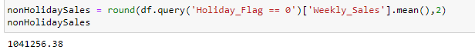

Lastly we made a dictionary that has all the calculations we done above to display it as a plot

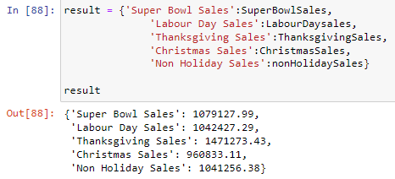

To answer the question we made a for loop that displays if the I indexed element in the result is higher than the non holiday season

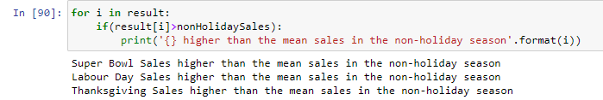

And finally we displayed the resulted data :

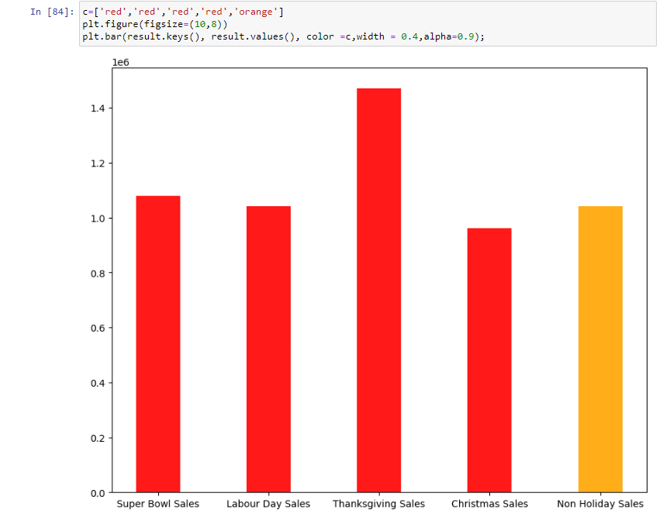

e) observing the relation between the weekly sales and temperature

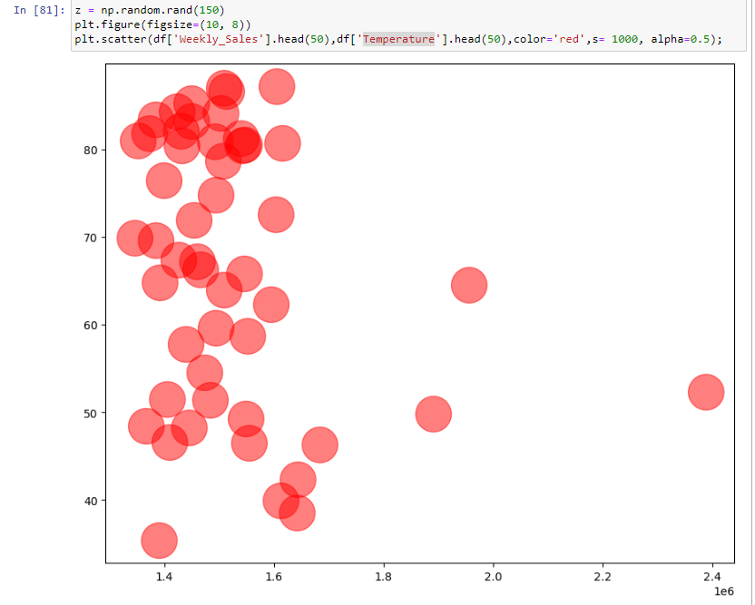

Observing the relation between the sales in every season of the year

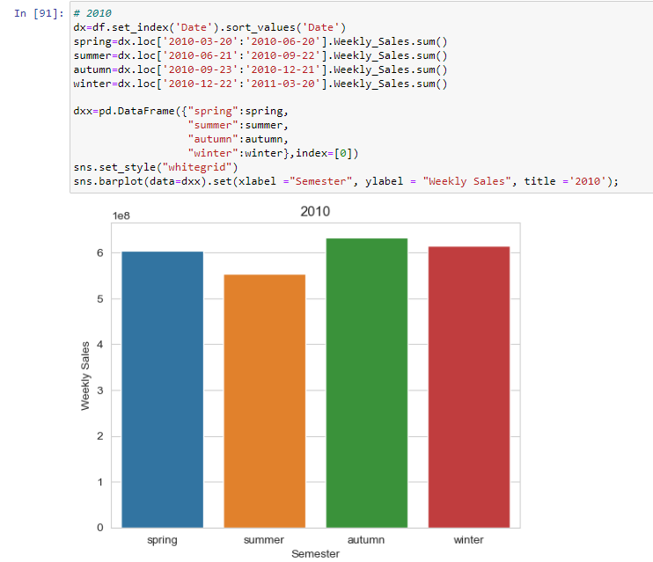

Observing the relation between the Unemployment and weekly sales

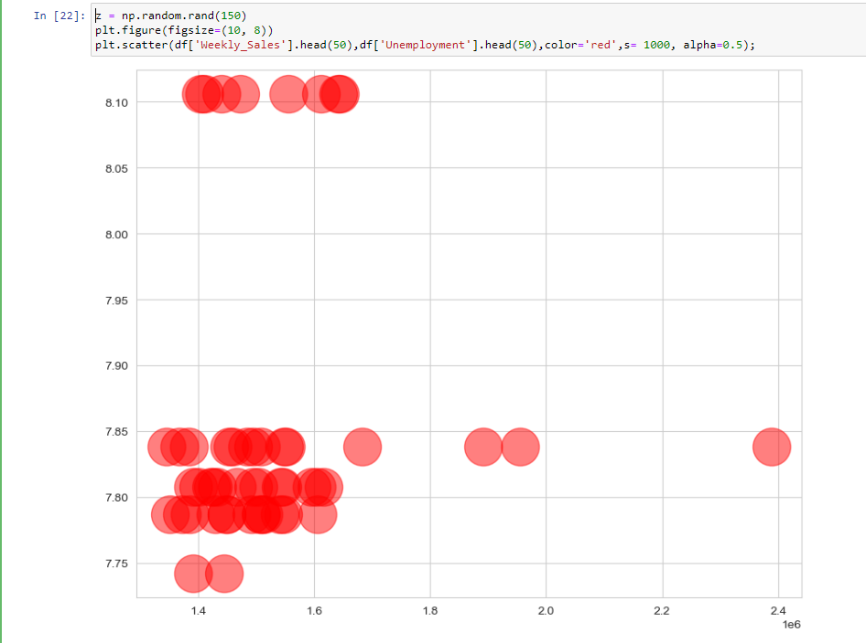

Observing the relation between the CPI in and weekly sales

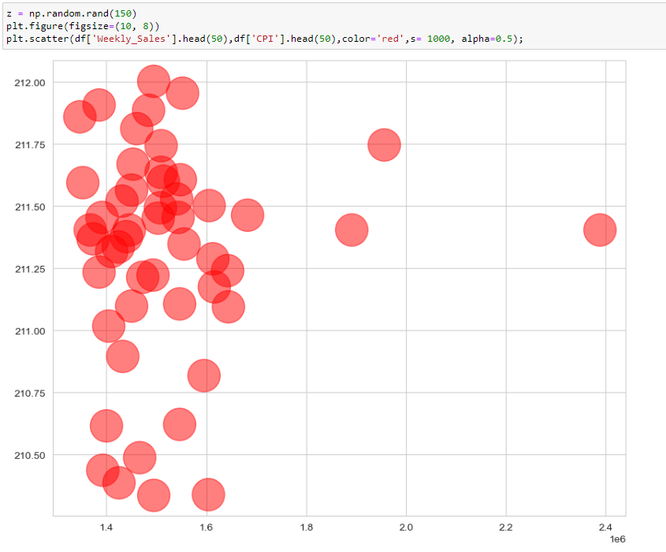

Observing the relation between the fuel price and weekly sales

